Chapter 2 Data Analysis Kron

2.2 Scientific Notation
M x 10^{n} *** all digits in Sci Not are significant***
1 ≤ M < 10
n = integer (…-2,-1,0,1,2…)

1. 63000 2. 0.000372 3. 34004303000 4. 3.45 x 10⁻³ 5. 2.34 x 10⁷

Significant Figures (Sig Figs) __________________!!

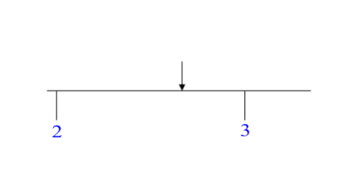
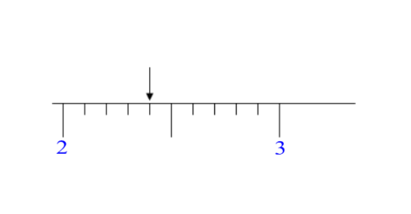
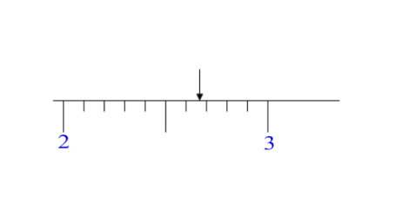
Sig Figs
*

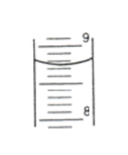
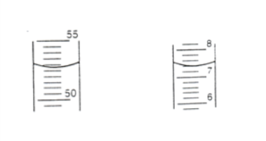
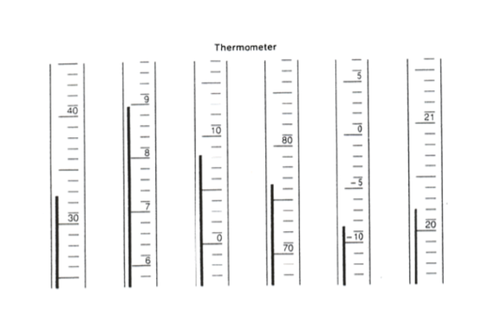

Rules for determining sig figs

1.

2.

A. Trailing zeros (that follow a non-zero number) with no decimal point (not SF's)

10000 3207000 2.3000 1000.0 1.00 x 10²⁸
B. Zeros used to indicate place (leading zero's in front only). (not SF's)

0.000670 0.00343 0.00303 1.00300300

** General Rule : **

** All digits listed in Sci Not are significant**
1.35 x 10² 2.3 x 10⁵ 3.60 x 10⁵

** ** (BASICALLY IGNORE)
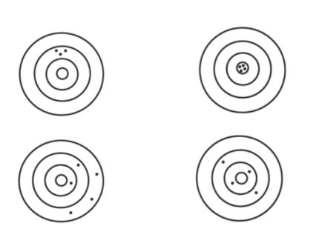
__________________
* refers to how close a measured value is to the accepted value

__________________
* refers to how close a series of measurements are to each other

Accepted = 11.50
Group A 10.50 12.53 13.58 15.35
Group B 11.75 10.50 12.50 11.25
Group C 11.52 11.51 11.49 11.50
Group D 13.52 13.54 13.55 13.53

Relative Error (E_{R}) (Percent Error) (% error)

E_{R} = Units reported as %

** sig figs are based on the number of the observed (lab)**
*** report to same number of sig figs***

A =
O =

2.1 Units of Measurements

SI measurement (Le Systèm International d'Unités)
* * *

Standards
*

Fundamental SI units
*
______________________
* combination of fundamental units

Example :

Prefixes
Base ten system, easy to convert. Must learn!!

Dimensional Analysis (converting)
* a method of converting using units as algebraic factors ( )

Conversion factors
* ratio derived from units ( )
Example:
234 km → m?

1000 ms → hs?

345 kL →mL?

25.34 oz →kg?

1.3 yrs →s?

35 cm³ → m³?

125 in² → cm²?

403 m/s → cm/hr?

875 yd → mm?

2.4 Representing Data

Variable
-

Direct Proportion / Direct relationship
* dividing two variables gives a constant
*

Inverse Proportion (indirect)
* product of two variables has a constant
*

